Understanding Invitations: Literacy homework, Friday 26th June 2026
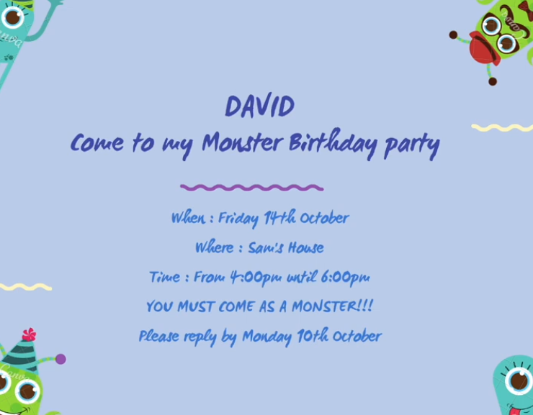
- What is the theme of the party? ____________________
- What time does the party end? _____________________
- What time of the year if this? ______________________
- Why is the party being held? ________________________
- Make an invitation for a party you would like to have.


