Understanding Invitations: Literacy homework, Friday 26th June 2026
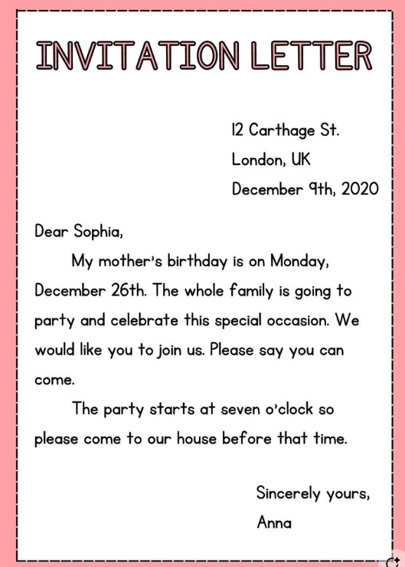
Using the information in the letter above, create an invitation for this event. Decorate suitably for the time of year.

