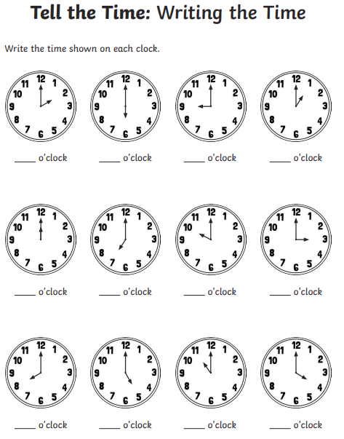
Maths homework challenge 1 Due 1/7/26

