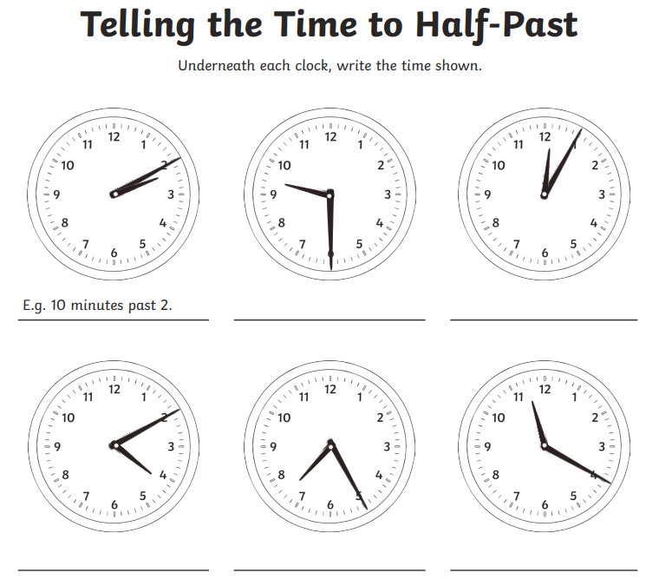
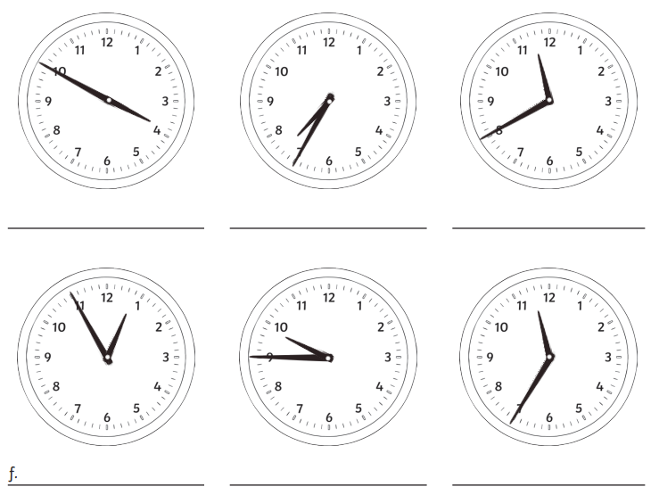
Eg: 2:10
Maths homework challenge 2 Due 1/7/26

