Maths Homework- Due: 8.7.26

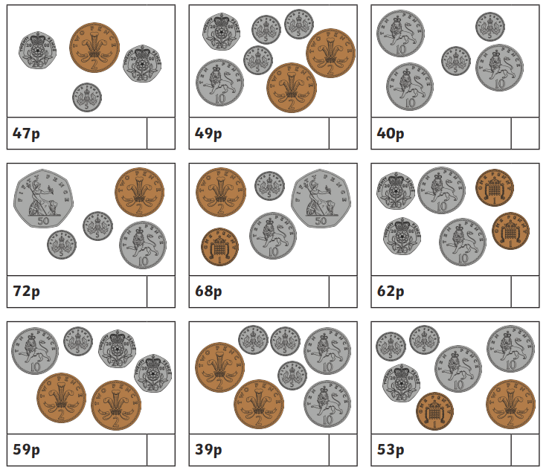
Count the coins and write the total

