Point and read the tricky words – make sure you are confident with them
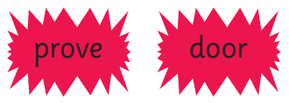



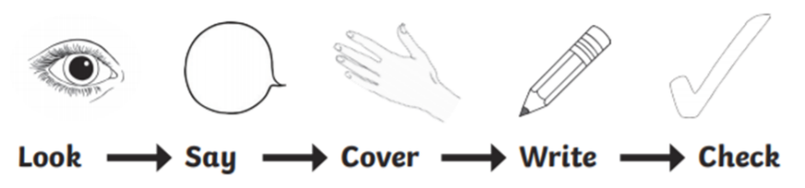

Word | Day 1 | Day 2 | Day 3
prove
shoe
parents
half
door
move

