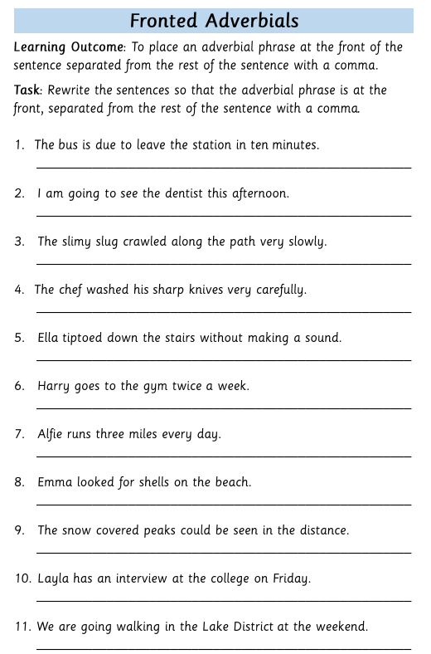
In ten minutes, the bus is due to leave the station.

