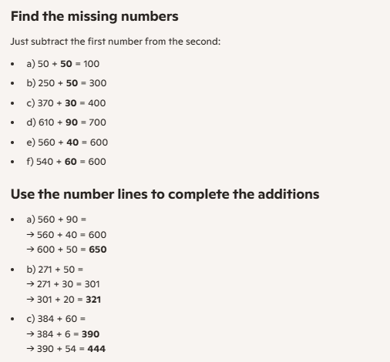
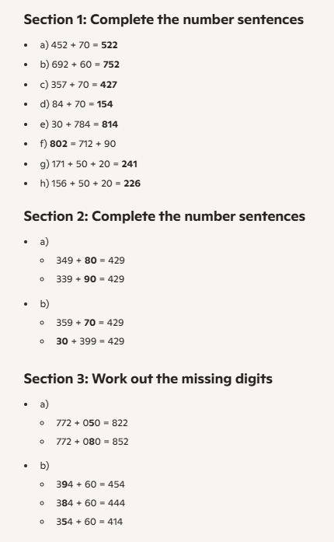
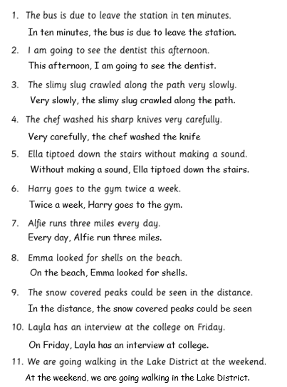
- Mum cautiously washed the sharp knives.
- Jack was ravenous and ate his burger quickly.
- The snow fell silently through the night.
- The crowd cheered brightly when a goal was scored.
- The snail crawled slowly along the path.
- Suddenly it began to rain.
- On Friday I am going bowling.
- The children sang happy birthday with gusto.
- The fire burned brightly in the grate.
- Yesterday I went to the cinema with my friend.

