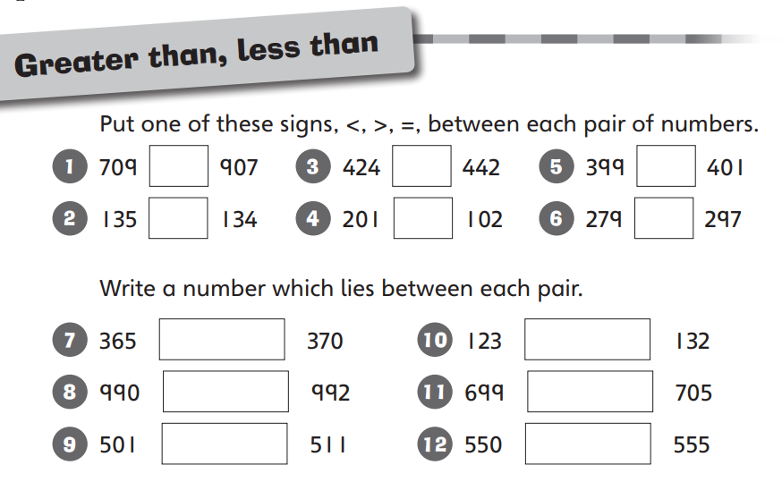
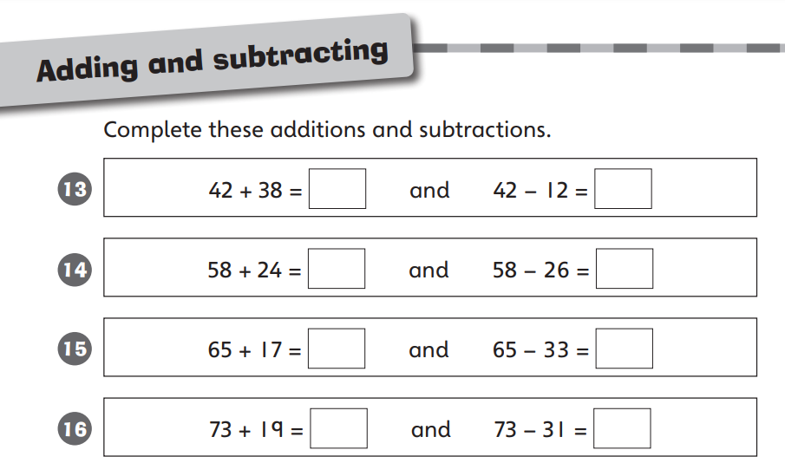
Maths challenge 3 Due 23.9.26

Maths challenge 2 Due 23.9.26
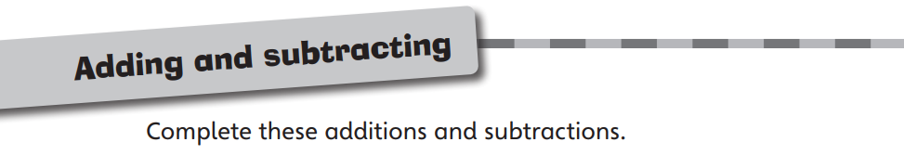


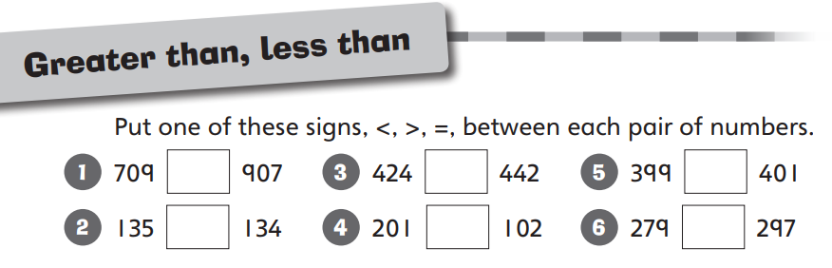
38 – 3 =
8 – 3 =
89 – 5 =
9 – 5 =
66 – 4 =
6 – 4 =
75 – 2 =
5 – 2 =
49 – 3 =
9 – 3 =

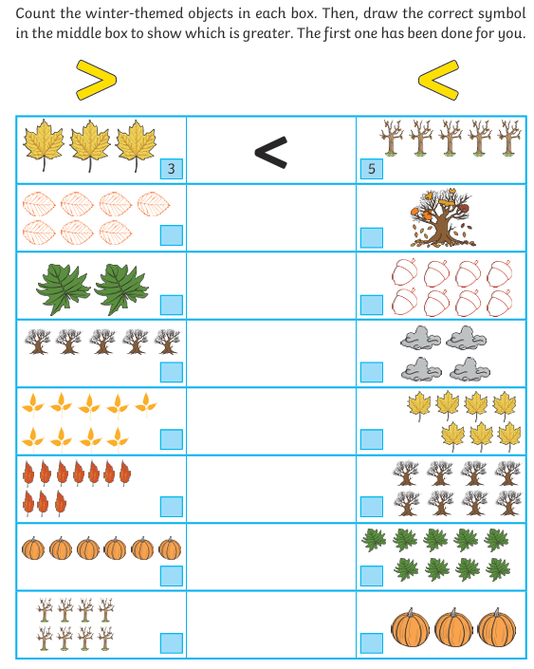
Maths challenge 1 Due 23.9.26

