For each question below, partition the second number to help you subtract mentally.
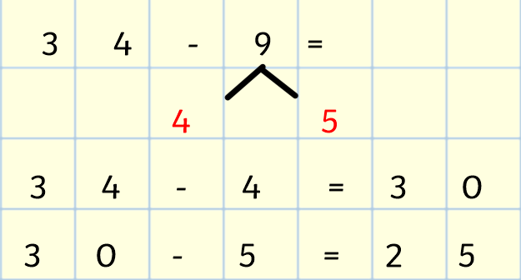
Example: 34 − 9 → Partition 9 into 4 and 5
34 − 4 = 30 (to find nearest 10)
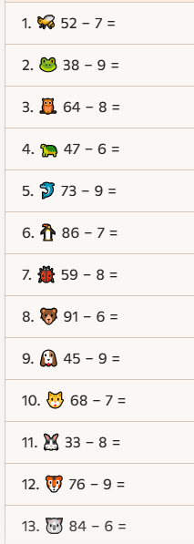

30 − 5 = 25 (subtracting what’s left) ✅ Answer: 25

