Over the half term break, we encourage all Year 1 children to continue their reading journey at home. Whether it’s a favourite storybook, a non-fiction text, or something new from the local library, every reading moment counts.
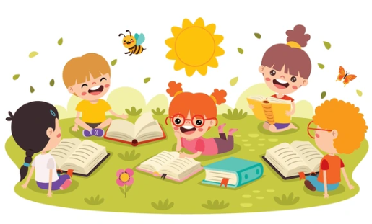
Please support your child in reading regularly and remember to record each session in their Reading Record.
Thank you for your support!
We look forward to seeing all the wonderful books you’ve explored when we return!
Miss Staples, Mrs Kluge and Mrs Loftus


