Year 3 Where in the World
Dear Parent/Carer,
‘Where in the World’ provides children with the opportunity to work independently, to find out more about a country that is of interest to them. The country may be where extended family live, one that children have visited or just a country that is fascinating.
‘Where in the World’ enables a celebration of a country every week, allowing us to share knowledge about the amazing cultural diversity in our class. One child from each class, each week, will be able to give their presentation.

When it is their turn, your child is welcome to bring into school:
- Finger-food from their country
- A PowerPoint presentation or photos (sent to their teacher’s email (fmwale@olqoh.com jjohnston@olqoh.com)
- Religious items or souvenirs from that country
- Videos/music links they would like to show Any other special items
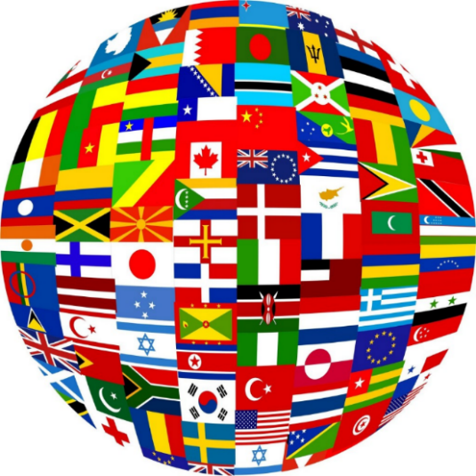

We look forward to learning all about your country…
Year 3 Where in the World
Dear Parent/Carer,
‘Where in the World’ provides children with the opportunity to work independently, to find out more about a country that is of interest to them. The country may be where extended family live, one that children have visited or just a country that is fascinating.
‘Where in the World’ enables a celebration of a country every week, allowing us to share knowledge about the amazing cultural diversity in our class. One child from each class, each week, will be able to give their presentation.

When it is their turn, your child is welcome to bring into school:
- Finger-food from their country
- A PowerPoint presentation or photos (sent to their teacher’s email fmwale@olqoh.com jjohnston@olqoh.com)
- Religious items or souvenirs from that country
- Videos/music links they would like to show Any other special items

We look forward to learning all about your country…

