Shape vocabulary
Roman numerals
Complete the grid.
Angles
Complete the grid.
Year 6 maths quiz: memory mastermind!

Fractions, decimals & percentages

Complete the conversion grid.
Multiplication and division vocabulary

- List all the factors of 36:
- List all the common factors of 24 and 32:
- List all the prime numbers under 20:
- What’s a composite number?
- What are the prime factors of 12?
- List the first 6 multiples of 9: , , , , and
- What is the lowest common multiple of 4 and 6?
- List 3 different square numbers: , and
- What is 3³?

Fraction | Decimal | Percentage
½
 | 0.2
 |  | 1%
¾
 | 0.25
 |  | 5%

How many degrees…
in a full turn? | °
in a half turn? | °
in a right angle? | °
in an acute angle? | °
in an obtuse angle? | °
in a reflex angle? | °
on a straight line? | °
inside a triangle? | °
inside a quadrilateral? | °

Draw a horizontal  line. | Draw a vertical line. | Draw a pair of parallel  lines. | Draw a pair of  perpendicular lines. | Label this circle with its  circumference, radius and  diameter.

1 = | I | = | X | 100 = |  | 1000 =
= | V | 50 = |  | = | D

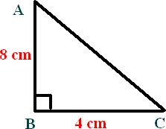
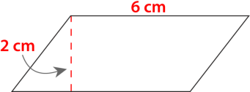
2D shapes

Complete the grid.
Name | No. of sides
octagon
 | 5
nonagon
 | 7
quadrilateral
 | 10
hexagon

What is a polygon?

What’s the difference between a regular an irregular polygon?

What is the area of this triangle? Area =

What is the area of this parallelogram? Area =

Below each shape, write its name (don’t just write ‘triangle’ for the first 3 – be specific!)

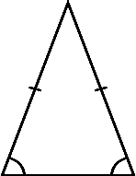 | 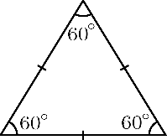 | 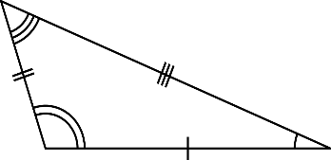 | 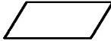 | 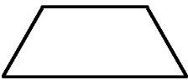 | 

Measurement conversions

- List all the months that have exactly 31 days:
- List all the months that have exactly 30 days:
- What’s different about a leap year?

Complete the conversions.

1cm = mm | 1km = m | 1 litre = ml
1m = cm | 1 mile = km | 1 kilogram = g
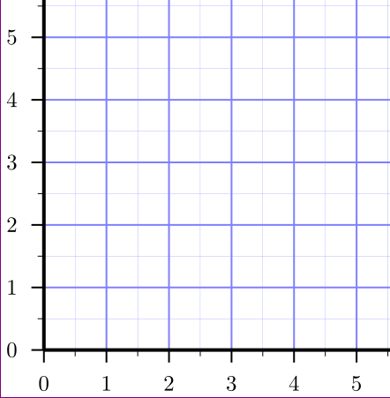
Co-ordinates Write an X on the co-ordinate (3,5).
The mean
What is the mean of the following numbers?
5, 7, 2, 8, 3
Mean =

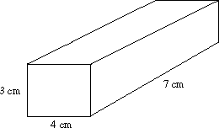
3D shapes
What’s the volume of this cuboid?

Complete the grid. | 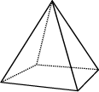 | 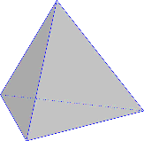 | 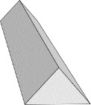
What is this shape called?
How many faces does it have?
How many edges does it have?
How many vertices does it have?

