
Our Lady Queen of Heaven Catholic School
Pupil Premium Strategy Statement

Pol
September 2025
Listen, Love, Learn
At Our Lady’s –

We are inspired, strengthened and encouraged by our Catholic faith.
We place Jesus at the centre of everything we do and say, listening to Him with our hearts.
We spread love everywhere we go, valuing and caring for each other.
We strive to be the best learners we can, using and celebrating our God given gifts.
“For he who is mighty has done great things for me, and Holy is his name” Luke 1: 49



"It is not enough to love the young; they must know that they are loved."
Don Bosco

Our Lady Queen of Heaven Catholic Primary School

This statement details our school’s use of pupil premium funding to help improve the attainment of our disadvantaged pupils.
It outlines our pupil premium strategy, how we intend to spend the funding in this academic year and the outcomes for disadvantaged pupils last academic year.

School overview
Detail | Data
Number of pupils in school | 49
Proportion (%) of pupil premium eligible pupils | 10%
Academic year/years that our current pupil premium strategy plan covers (3-year plans are recommended – you must still publish an updated statement each academic year) | 2024-2025, 2025-2026, 2026, 2027
Date this statement was published | October 2025
Date on which it will be reviewed | Spring Term 2026  Summer Term 2026
Statement authorised by | Tobias Melia
Pupil premium lead | Annabel Jannece and Clare Reddick
Governor / Trustee lead | Jan Miles

Funding overview
Detail | Amount
Pupil premium funding allocation this academic year | £82,136
Pupil premium funding carried forward from previous years (enter £0 if not applicable) | £0
Total budget for this academic year  If your school is an academy in a trust that pools this funding, state the amount available to your school this academic year | £82,136

Part A: Pupil premium strategy plan

Statement of intent

School Context
Our Lady Queen of Heaven is a Catholic school that welcomes pupils from a wide range of faiths and cultural backgrounds. We celebrate diversity and foster an inclusive environment where every child is known and loved. We have a higher-than-average proportion of pupils who speak English as an Additional Language (EAL) and a slightly higher proportion of pupils with Special Educational Needs and Disabilities (SEND) than the national average.
We are committed to ensuring that all pupils—regardless of background—have access to a wealth of opportunities that support their social, emotional, physical, and academic development. We believe that every child should feel safe, valued, and empowered to achieve their greatest potential.

Intent of Our Pupil Premium Strategy
The core aim of our Pupil Premium Strategy is to raise standards and aspirations for disadvantaged pupils, including those who are already high attainders. We are determined that all disadvantaged pupils make good progress and achieve high attainment across all subject areas.
We aim to:
- Provide high-quality teaching and personalised educational support.
- Offer enriching opportunities that pupils may not otherwise access.
- Ensure equity in educational outcomes through targeted interventions and inclusive practices.
- Strengthen foundational academic skills to ensure long-term academic success.
- Inspire ambition provide pupils with life skills to support them in their future education and life.
We also recognise that not all families who are eligible for Pupil Premium funding apply for it. As a result, we remain proactive in identifying pupils who may benefit from additional support, regardless of formal funding status. Our inclusive approach ensures that we aim to ensure no child is left behind due to administrative barriers.

Challenges
This details the key challenges to achievement that we have identified among our disadvantaged pupils.
Challenge number | Detail of challenge
1 | A language deficit - both a gap in vocabulary and a lack of ability to manipulate language for effect.
2 | Pupils in receipt of PPG historically have not achieved in reading and writing in line with their peers. This gap is closing but still remains a focus ensuring pupils meet their full potential.
3 | Limited Cultural capital and enrichment - lack of experiences and opportunity. Family circumstances may limit opportunities to participate in co-curricular activities.
4 | Social and emotional issues resulting in low confidence and self-esteem, which affects behaviour for learning and a family’s ability to support learning.
5 | Average attendance and punctuality of PPG children is below that of their peers.
6 | We have noticed that it has been increasing challenge in ensuring parents understand their eligibility for pupil premium and knowing how to access information and complete the application process, this is especially true in EYFS and KS1 with there being with 82% of PP pupils being in KS2.

Intended outcomes
This explains the outcomes we are aiming for by the end of our current strategy plan, and how we will measure whether they have been achieved.
Intended outcome | Success criteria
Key Stage Outcomes  Pupils eligible for PPG in all year groups to increase progress and attainment at least in line with National Averages and closing the gap on their Non PP peers in reading and writing. | Teachers in all year groups have identified the gaps in learning and planned to close them.  Analysis of data termly has accurately identified pupils that need additional support in reading and writing.  Teachers use accurate reading data for most able disadvantaged pupils in the school. Gap analysis termly testing and interventions where needed.  End of Key stage data will show that children eligible for Pupil Premium are in line with their peers and national averages or are making significant progress to close the gap.
EYFS  Increase the number of targeted children achieving ELGs. Particularly in Communication and Language, Physical Development and Personal and Social Development. Giving them the skills to be successful learners throughout their education. | A greater number of children achieve Age related expectations.  Children show good progress against teacher baseline data and language interventions- NELI programme.
Phonics  Targeted pupils to reach ARE/pass Phonics Screening Check in Year 1 and Year 2. To reduce the gap between NPP and PP pupils.  KS2 pupils not meeting ARE in reading to be given targeted intervention. | Data will reflect that a greater number of children eligible for Pupil premium will pass the phonics-screening test.  Data will show that PP children make good progress in reading.
Attendance  Improving the attendance of pupils eligible for pupil premium funding by ensuring a high level of parental engagement with their child’s learning and access to emotional well-being support for children and their families  Opportunities are created for targeted children to access individualized therapies and support systems pertinent to identified needs. | Attendance data for pupils in receipt of PPG will have closed the gap with national expectations.  The Inclusion team and all staff will identify and engage with children and families to alleviate barriers to learning.  Identified children/ families will work with the Learning Mentor/ ELSA, Primary Mental Health Support Team, Educational Psychologist and Speech and Language to ensure barriers have the least effect on progress, attainment and attendance as possible.
Cultural Capital  Targeted children have increased opportunities to access and engage in a wide range of co-curricular activities.  To develop social skills, confidence, provide new opportunities, encourage healthy life styles and develop life skills. | All PPG pupils will be offered opportunities to attend clubs, musical activities, trips and enrichment opportunities.  The Green card system will continue- offering parents funding to be able to pay for clubs and resources to enhance opportunities.  Tracking data and pupil voice evidences increased participation and access.  Enrichment opportunity tracking within school and extra-curricular opportunities will indicate that all PPG pupils have taken part in enrichment opportunities.  Year group and Curriculum maps will identify enrichment opportunities provided within classes and subjects.
Social and Emotional Health  To develop emotional literacy to support children to be able to manage emotions.  To develop children’s confidence and independence as a learners.  Implement a new whole school rewards system to help motivate behavior and academic success and progress. | Targeted children demonstrate increased confidence and resilience as evidenced through observation and pupil voice surveys.  Uptake and pupil voice to evidence the impact of targeted opportunities such as Junior Duke, roles and responsibilities and rewards systems.  Whole school zones of regulation strategy and individual tool boxes to allow children to better understand and support their own emotions.  3 Before Me encouraging pupils use and develop strategies to become independent learners as evidenced in learning walks, observations, book looks and pupil views.
PP sign up  An increased number of parents complete the eligibility for PP form and feel supported in doing so. This further results in an increased number of children eligible for PP being identified. | The percentage of children eligible for PP will increase, Funding increase to support them in school and offers such as the Green Card initiative supporting more families.

Activity in this academic year
This details how we intend to spend our pupil premium funding this academic year to address the challenges listed above.

Teaching (for example, CPD, recruitment and retention)
Budgeted cost: £48,285
Activity | Evidence that supports this approach | Challenge number(s) addressed
All classes from EYFS to Year 6 to have support from skilled support staff. Allowing nurture groups, teaching groups and interventions across the school to run with less interruption. | Some pupils may require additional support in order to make good progress. Evidence indicates that small groups can be a powerful tool for supporting these pupils when they are used carefully. 2. Targeted academic support | EEF (educationendowmentfoundation.org.uk) | 1, 2, 4
Outside consultants and advisors to work with school staff to enhance teaching knowledge and strategies and ensure high-quality teaching provision for all disadvantaged children.  SALT support  EP support  West Sussex Services- Young Carers  BOSCO Math Lead | Evidence suggests that professional development offers a crucial tool to develop teaching quality and subsequently enhances children’s outcomes in the classroom. EEF-Effective-Professional-DevelopmentGuidance-Report.pdf (d2tic4wvo1iusb.cloudfront.net) | 1, 2, 4
To access expert skills and delivery of CPD from expert teachers to enhance curriculum development particularly in reading, writing and maths.  We are part of the BOSCO Academy which provides specialist lead support for Maths and English.  All subject leads are given the opportunity to hold staff meetings to provide updates and CPD for teaching staff.  Staff are given opportunities to access online and in person CPD to enhance teaching and learning (National College)  EYFS are taking part in the NFRE Math Jigsaw trail. Offering targeted math CPD for staff. | The EEF research states that on-going personal and professional learning allows for critical reflection and development of expertise. | 1, 2, 4
OLQOH to employ Private Speech and Language Therapist to help identify pupils and upskill school staff in supporting those children with a SALT need. |  | 1
To provide training and mentoring for new members of staff to ensure they are confident in delivering the curriculum and supporting all learners.  To monitor the delivery of teaching and learning through internal subject leader monitoring including scrutiny of work and moderation activities. Along with learning walks, networking meetings and observations. | EEF states that schools should ensure every teacher is supported in delivering high-quality teaching as this is essential to achieving the best outcomes for all pupils, particularly the most disadvantaged among them. 1. High-quality teaching | EEF (educationendowmentfoundation.org.uk | 2
SENDco and PP leads to develop tracking of support for PP children.  School provision map to be used to document and track support for all PPG pupils. OLQH are aware that research shows that higher attaining PP pupils are less likely than their non PP peers to achieve their full academic potential. Tracking and monitoring provision for all PPG pupils will help to prevent this. | The DfE Menu of Approaches outlines ‘developing high quality assessment procedures… which responds to the needs of pupils’. | 2,3
Senior Leaders to ensure Pupil Premium is a focus during progress and attendance meetings so that class teachers can show progress through QFT and interventions and co-curricular participation |  | 2, 3, 5

Targeted academic support (for example, tutoring, one-to-one support, structured interventions)
Budgeted cost: £13,413
Activity |  | Evidence that supports this approach |  | Challenge number(s) addressed
To provide tutoring and support for identified pupils led by QTS staff who know the children  Extended school time- e.g. Easter School for targeted groups. |  | Tuition targeted at specific needs and knowledge gaps can be an effective method to support low attaining pupils or those falling behind:  Small group tuition | Teaching and Learning Toolkit | EEF |  | 2
 | Teaching Assistant time ring fenced to allow for NELI intervention |  | Research shows that the Nuffield early language intervention allows participating pupils to make significantly more progress than their language skills. Oral language forms a crucial foundation for thinking, learning and social interaction and is one of the strongest predictors of success in literacy and numeracy and later employment and welling being (EEF A Tiered Approach p14) |  | 1,2, 4
 | Teacher and Teaching Assistant ring fenced time to allow deliver target literacy interventions- |  | Some pupils may require additional support in order to make good progress. Evidence indicates that small groups can be a powerful tool for supporting these pupils when they are used carefully. 2. Targeted academic support | EEF (educationendowmentfoundation.org.uk)
 | Learning Mentor support to run interventions such as Thrive and WOWSI to support identified pupils and families. |  | There is extensive evidence associating childhood social and emotional skills with improved outcomes at school and in later life (e.g., improved academic performance, attitudes, behaviour and relationships with peers): EEF_Social_and_Emotional_Learning.pdf(educationendo wmentfoundation.org.uk) |  | 4
 | EWO support to work with identifies families and improve pupil attendance. |  | Following guidance from the DfE’s Improving School Attendance advice. The EEF states that well-designed school communications can be effective for improving attainment and a range of other outcomes, such as attendance. EEF_Parental_Engagement_Guidance_Report.pdf (d2tic4wvo1iusb.cloudfront.net) |  | 4,5

Wider strategies (for example, related to attendance, behaviour, wellbeing)
Budgeted cost: £20,438
Activity | Evidence that supports this approach | Challenge number(s) addressed
To ensure all children access co-curricular enrichment activities and trips including residential opportunities in order to boost social development, improve learning skills, foster team working, build life skills and encourage creativity.  All PPG pupils to have a ‘green card’ to offer funding towards clubs and trips.  All year groups to plan extra curricular trips.  Activities week to provide children with extended opportunities. | Based on the EEF, it is believed that enriching education has intrinsic benefits and that all children, including those from disadvantaged backgrounds, deserve a well-rounded, culturally rich education. Life skills and enrichment | EEF (educationendowmentfoundation.org.uk) | 3
Subsidised cost of PGL trip in Year 6 to remove cost barrier. | Based on the EEF, it is believed that enriching education has intrinsic benefits and that all children, including those from disadvantaged backgrounds, deserve a well-rounded, culturally rich education. Life skills and enrichment | EEF (educationendowmentfoundation.org.uk) | 3
OLQOH to continue to be a HAF provider. Offering holiday childcare in a familiar setting, run by well qualified familiar staff. |  | 3
Summer Holiday Trips  During the Summer holidays OLQOH organizes day trips for pupils to local attractions. These can be funded by pupils Green Cards. | Based on the EEF, it is believed that enriching education has intrinsic benefits and that all children, including those from disadvantaged backgrounds, deserve a well-rounded, culturally rich education. Life skills and enrichment | EEF (educationendowmentfoundation.org.uk) | 3
Activities week  In the summer term OLQOH runs an ‘Activities Week’ offering pupils enrichment opportunities in sporting, arts, STEM and music activities events. | Based on the EEF, it is believed that enriching education has intrinsic benefits and that all children, including those from disadvantaged backgrounds, deserve a well-rounded, culturally rich education. Life skills and enrichment | EEF (educationendowmentfoundation.org.uk) | 3
Continue to promote ‘Thee Before Me’ across the school. Giving pupils the skills to independent learners. | There is extensive evidence associating childhood social and emotional skills with improved outcomes at school and in later life (e.g., improved academic performance, attitudes, behaviour and relationships with peers): EEF_Social_and_Emotional_Learning.pdf(educationendo wmentfoundation.org.uk) | 4
To make sure PPG pupils are given the opportunity to carryout roles across the school. E.g. School council, Science Leaders, Art Ambassadors. Allowing them opportunities to take part in discussions, support assemblies, attend and plan enrichment days/ trips. | There is extensive evidence associating childhood social and emotional skills with improved outcomes at school and in later life (e.g., improved academic performance, attitudes, behaviour and relationships with peers): EEF_Social_and_Emotional_Learning.pdf(educationendo wmentfoundation.org.uk) | 3, 4
To identify and support those children requiring support with developing social skills, self-esteem and positive behaviour choices.  New behavior/ reward system to be rolled out across the school.  Use of  Zones of Regulation across the school and targeted support for identified pupils. | There is extensive evidence associating childhood social and emotional skills with improved outcomes at school and in later life (e.g., improved academic performance, attitudes, behaviour and relationships with peers): EEF_Social_and_Emotional_Learning.pdf(educationendo wmentfoundation.org.uk) | 4
Run Junior Duke Award for identified PPG pupils to develop life skills and provide opportunities to encourage independence, resilience and self-motivation and they work towards the award. | Junior Duke is aimed to encourage independence, confidence, resilience and self-motivation. Junior Duke is aimed at helping children aged 7 to 11 to learn and practice a large variety of life skills. | 3, 4
Attendance of pupils will be monitored by leaders so that support for families where required can be given prior to implementing more punitive measures.  Class teachers will be given daily absence reports to inform discussions with parents.  SLT to meet with families of children whose attendance is a concern to support and put a plan into place.  QLQOH to purchase support from EWO who can work with identified families. | Following guidance from the DfE’s Improving School Attendance advice. The EEF states that well-designed school communications can be effective for improving attainment and a range of other outcomes, such as attendance. EEF_Parental_Engagement_Guidance_Report.pdf (d2tic4wvo1iusb.cloudfront.net) | 5
Pupil Premium sign up support.  Pupil Premium leads and office staff to offer support to families when completing application if required.  Regular newsfeed updates throughout the academic year signposting parents to the FSM application forms | Following guidance from the DfE’s Improving School Attendance advice. The EEF states that well-designed school communications can be effective for improving attainment and a range of other outcomes, such as attendance. EEF_Parental_Engagement_Guidance_Report.pdf (d2tic4wvo1iusb.cloudfront.net) | 6

Total budgeted cost: £82,136

Part B: Review of the previous academic year

Outcomes for disadvantaged pupils
Pupil premium strategy outcomes
This details the impact that our pupil premium activity had on pupils in the 2024 to 2025 academic year.
Intended Outcome 1: Pupils eligible for PPG in all year groups to increase progress and attainment, closing the gap on their Non PP peers in reading and writing.
During the 2024–2025 academic year, the school has made strides in supporting pupils in receipt of the Pupil Premium Grant (PPG). Notably, attainment among PPG pupils in Key Stage 2 (KS2) is higher compared to Key Stage 1 (KS1).
This can be attributed to several key factors:
- Specific SEND Needs: A higher proportion of pupils in KS1 have Special Educational Needs and Disabilities (SEND), which can impact overall attainment data.
- Disadvantaged cohort numbers: The smaller number of PPG pupils in KS1 means that each individual’s performance has a greater statistical impact on overall outcomes.
- SALT and EAL Needs: Many KS1 pupils require Speech and Language Therapy (SALT) support or are at the early stages of learning English as an Additional Language (EAL). These needs can initially affect attainment but tend to diminish over time.
- EAL Progression: Historically, EAL pupils tend to close the attainment gap as they progress through school, often achieving parity or better outcomes by KS2.
These improvements reflect the success of targeted interventions and whole-school strategies aimed at raising achievement for disadvantaged pupils. Although the data suggests disadvantaged pupils are not achieving inline with their peers, the closing gap between literacy and numeracy is largely positive.

Throughout the year, identified Pupil Premium pupils have benefited from a range of additional support, including:
- SALT support
- Language interventions (e.g. Mastery folders)
- Targeted phonics and literacy groups
- Daily reading
- Pre-teaching sessions
- Accelerated Reader programme
 | Year 1 | Year 2 | Year 3 | Year 4 | Year 5
Reading | 50% | 25% | 75% | 67% | 89%
Writing | 33% | 25% | 75% | 67% | 67%
Maths | 33% | 25% | 50% | 75% | 89%
KS1 and KS2 Data: Historically, Pupil Premium pupils have performed better in Mathematics than in Literacy. However, this year, that gap has narrowed, with some year groups now achieving higher outcomes in Literacy than in Maths, this is especially true in KS1 and lower KS2 where there is a high focus on language development. This shift highlights the success of the school’s focused efforts to raise literacy attainment among disadvantaged pupils.

Intended Outcome 2:
Early Years Foundation Stage (EYFS) – Pupil Premium Progress 2024–2025
Disadvantaged pupils in the EYFS have made strong progress, particularly in the Prime Areas of Learning. Although data shows that some disadvantage pupils’ language skills are below that of their non-PP peers, the impact of targeted interventions, including Speech and Language Therapy (SALT) and the NELI (Nuffield Early Language Intervention) programme, has been clearly evidenced. At the start of the year, 66% of disadvantaged pupils’ language skills were assessed as ‘a clear cause for concern’. By the end of the year, assessments showed that these concerns had been addressed, with 100% of disadvantaged pupils now assessed as ‘no cause for concern’ in language development.
Although Good Level of Development (GLD) has not yet been achieved for all pupils, the progress made from individual starting points is significant and reflects the effectiveness of early intervention strategies.

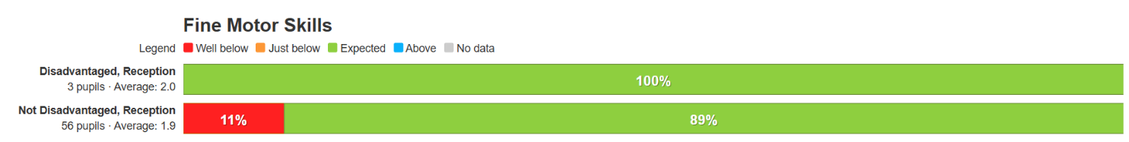
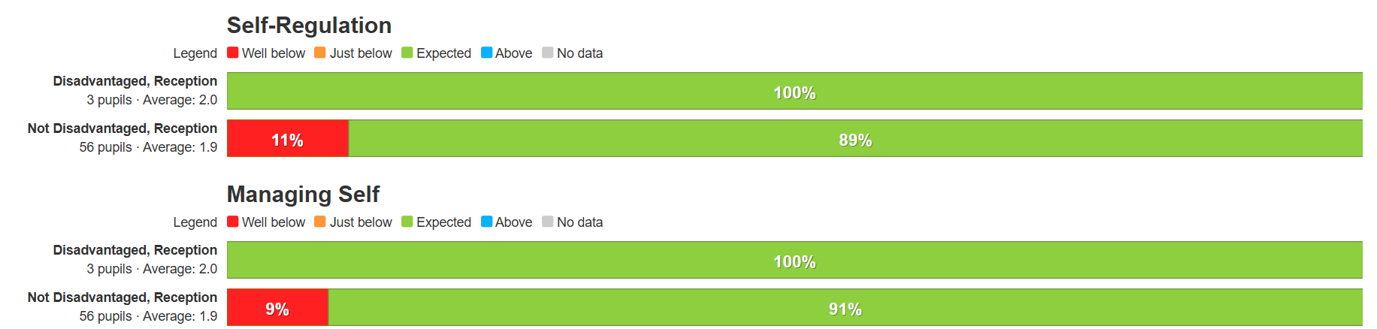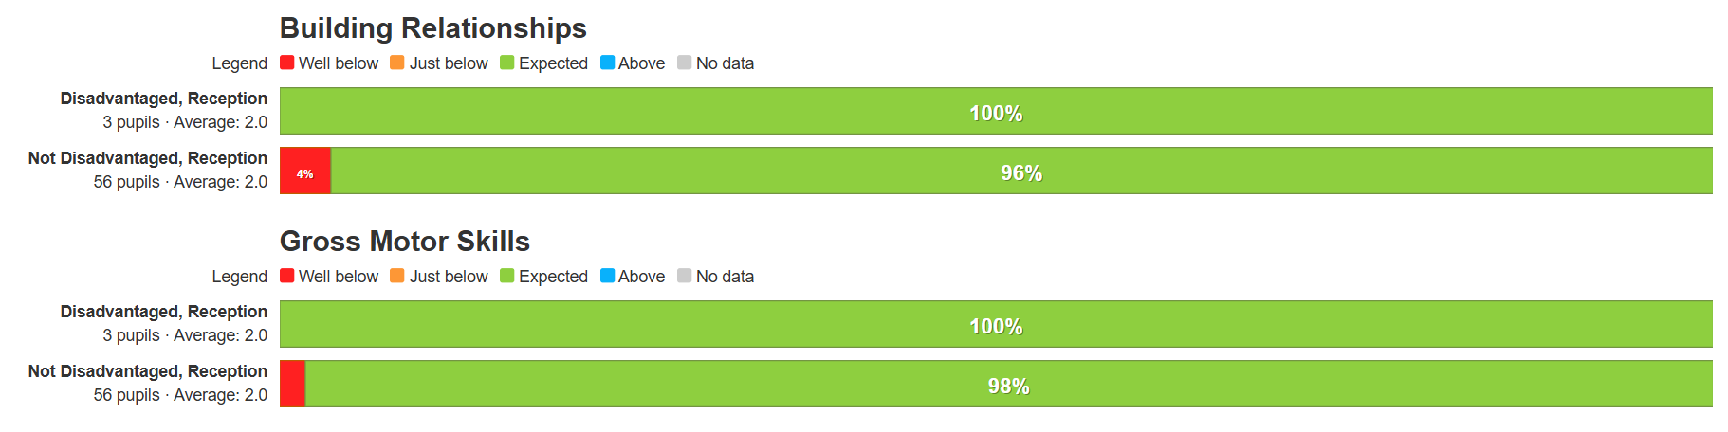

Intended Outcome 3:
KS1 Phonics
Targeted pupils to reach ARE/pass Phonics Screening Check in Year 1. To reduce the gap between NPP and PP pupils.

 | Year 1
Disadvantaged | 83%
Non Disadvantaged | 90%

While data indicates that disadvantaged pupils at OLQOH have achieved below their non-disadvantaged peers, it is important to consider the small cohort size of disadvantaged pupils within the year group. In such cases, individual pupil outcomes can have a disproportionate impact on overall data trends.
Despite this, outcomes for disadvantaged pupils at OLQOH are significantly above the national average for disadvantaged pupils in 2024, which stood at 68%. This demonstrates that, although the attainment gap remains, the school’s strategies and interventions are having a positive and measurable impact on pupil progress and

Intended Outcome 4:
Attendance
Improving the attendance of pupils eligible for pupil premium funding by ensuring a high level of parental engagement with their child’s learning and access to emotional and well-being support for children and their families

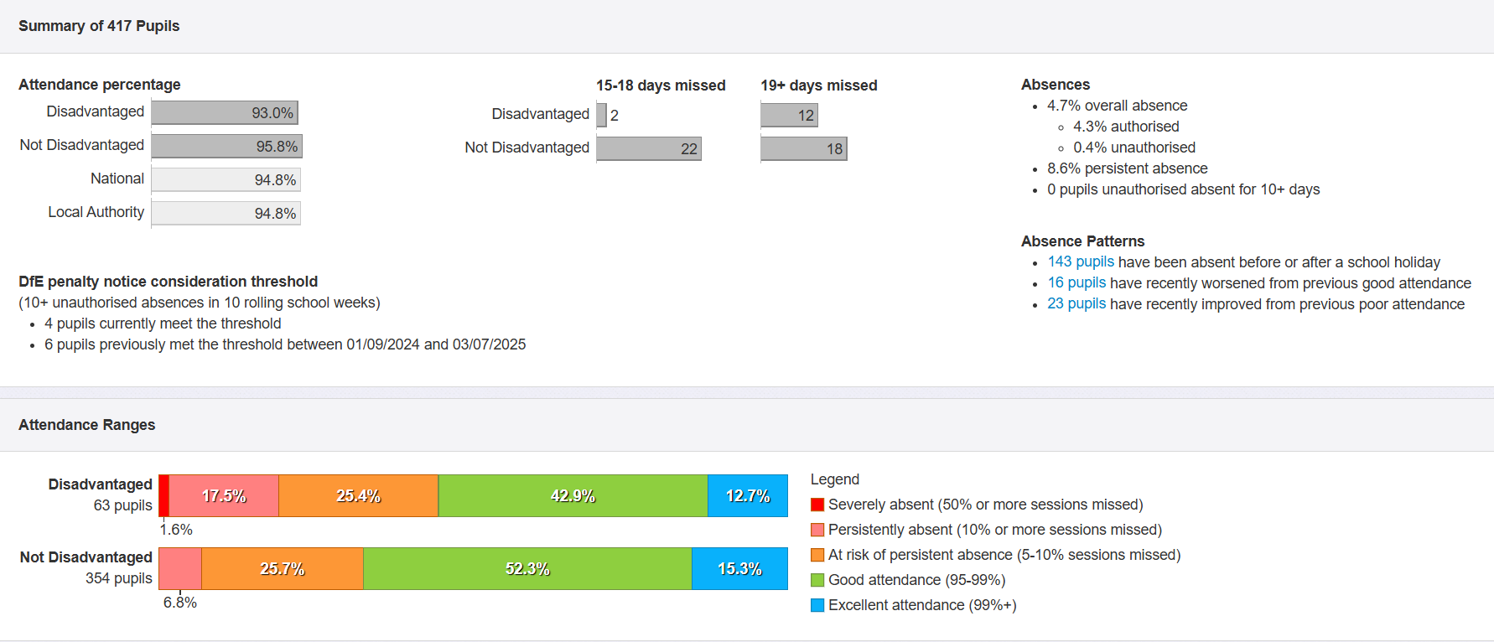
At OLQOH, a greater proportion of disadvantaged pupils fall into the persistently absent and severely absent categories compared to their non-disadvantaged peers. However, these figures are broadly in line with national attendance data, reflecting wider trends across the country.
To address this, the school has taken proactive steps during the 2024–2025 academic year:
Policy Review: The school’s attendance policy has been reviewed to ensure it is clearly structured, and progressive. It enabling staff to respond consistently and effectively to attendance concerns, while also ensuring early intervention and support for families.
EWO Partnership: OLQOH has begun working closely with an Education Welfare Officer (EWO) to engage families, identify barriers, and implement tailored strategies to improve attendance.
SEND/PP Crossover: For some pupils, attendance is impacted by health and SEND needs, this is taken into account and families are supported as needed.
Family Support: Senior leaders and the school learning mentor work collaboratively to support families facing challenges that affect school attendance.
Wraparound Care: The school offers a breakfast club and works in partnership with an afterschool provider to support families with childcare needs, helping to reduce logistical barriers to attendance.

Intended Outcome 5: Cultural Capital.
Targeted children have increased opportunities to access and engage in a wide range of co-curricular activities.

Curriculum Enrichment: Through a wide range of enriching learning experiences, we ensure that all pupils are exposed to opportunities that enhance their cultural capital and prepare them for life beyond the classroom. These include but are not limited to:
- Educational Visits: Trips to the Houses of Parliament, theatres, museums, farms, sporting events, cinema trips and the beach, Year 6 residential trip (partly funded for disadvantaged pupils)
- Community Engagement: Talks and workshops from local services such as St John Ambulance and the fire service.
- Cross-Sector Links: Partnerships with local secondary and independent schools to raise aspirations and provide insight into future pathways.
- Workshops and Enhancements: Both virtual and in-person workshops that bring learning to life and connect pupils with real-world contexts.
- Business and Local Setting Links: Collaborations with local businesses and guest speakers to provide meaningful, real-life learning experiences
These opportunities are embedded across all year groups, ensuring that every child benefits from a rich and varied curriculum that supports both academic achievement and personal development.

Removing Barriers to Participation
- Subsidised or Free Access: Part of the Pupil Premium funding is ring fenced to provide every disadvantaged pupil with a ‘green card’. Families can choose to fund clubs, pay for school trips or school resources such as uniform.
All Pupil Premium families have made use of this funding to support their child’s education.
- Parental Engagement: Workshops and shared experiences for pupil and parents have been offered: workshops around supporting emotional regulation, experience included a phunky food workshop to promote healthy eating and an active life styles course to promote physical activity for the whole family.
Junior Duke Award
A group of targeted disadvantaged pupils participated in the Junior Duke, designed to develop key life skills such as independence, resilience, and teamwork.
The award ran over 13 weeks and offered a wide range of practical, skill-building activities, including:
- Learning to mop a floor
- Growing their own vegetables
- Hand-washing clothes
- Preparing a healthy meal
- Planning and navigating a route to the shop
- Purchasing items from a shopping list
Pupil and parent feedback was overwhelmingly positive, with several pupils expressing interest in progressing to the next stage of the award. The programme not only equipped pupils with valuable life skills but also boosted their confidence and sense of achievement.

Intended Outcome 6: Social and Emotional Health
To develop emotional literacy to be able to manage emotions

- Pastoral care, mentoring, and emotional literacy support have helped pupils build resilience, confidence, and independence.
- Zones of Regulation and sensory circuits have continued to be used for targeted pupils, supporting emotional self-regulation and readiness to learn.
- A play therapist has delivered bespoke support for identified pupils with emotional and behaviour needs.
- The school learning mentor completed WOWSI project training, enabling OLQOH to offer this specialised support to disadvantaged families.
- Behaviour incidents among Pupil Premium pupils have been monitored. Positive playtimes has been a whole school focus. Staff received playground training, leading to the development of a zoned playtime approach. This has increased the range of structured activities available during break times, promoting positive social interaction and inclusion.

- The “Try 3 Before Me” strategy has been embedded in parts of the school, promoting pupil independence. This was noted in written feedback after a learning walk by our School Improvement Partner.
- The school inclusion team ran parent workshops and coffee mornings focused on supporting emotional regulation at home, this workshop had a higher uptake than similar workshops run in the past and parent feedback was overwhelmingly positive.

Externally provided programmes
Please include the names of any non-DfE programmes that you used your pupil premium to fund in the previous academic year.
Programme | Provider

Service pupil premium funding (optional)
For schools that receive this funding, you may wish to provide the following information: How our service pupil premium allocation was spent last academic year
One child attracts this funding.
Specific in class interventions are in place to support this child’s attainment and progress. Green Card funding
The impact of that spending on service pupil premium eligible pupils
Good end of year attainment
They attended an after school club each term and attended summer trips.

