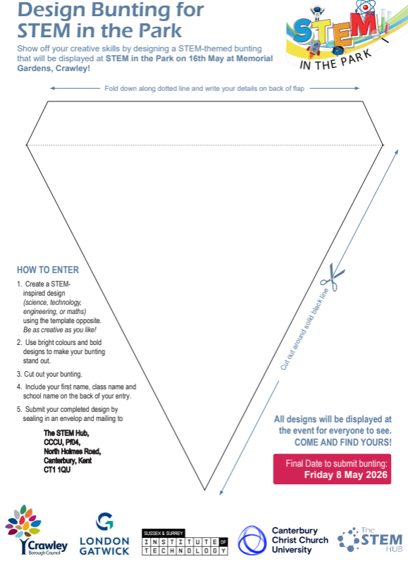

Hand in to your teacher by Friday 1st May

