Point and read the tricky words – make sure you are confident with them
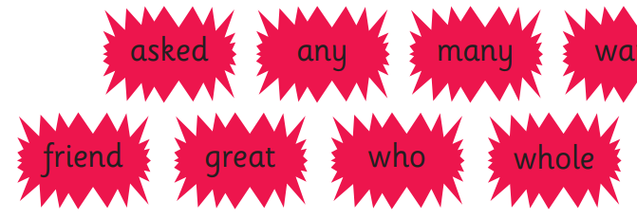

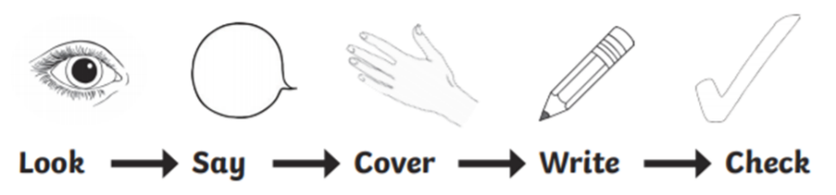

Word | Day 1 | Day 2 | Day 3
asked
any
friend
many
great
who

Point and read the tricky words – make sure you are confident with them:



Word | Day 1 | Day 2 | Day 3
put
push
pull
full

