Literacy Homework- due 6th May 2026 Challenge 2
Complete these sentences by adding a preposition:
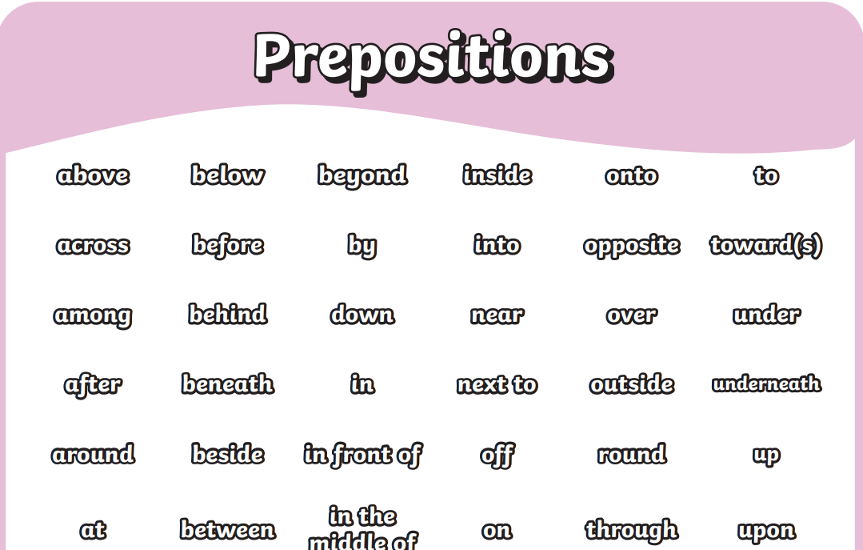

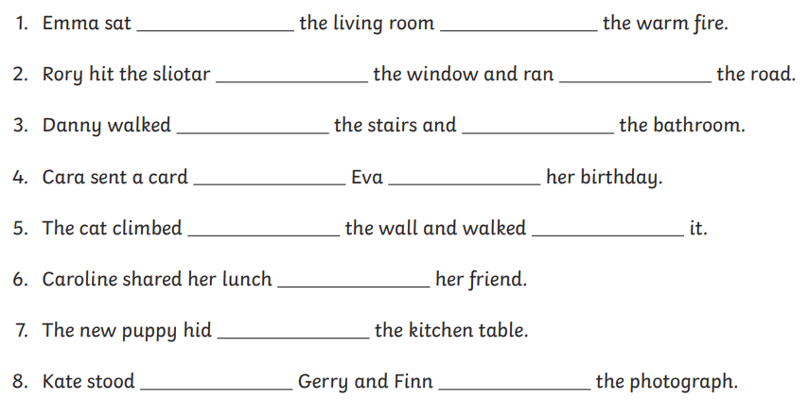

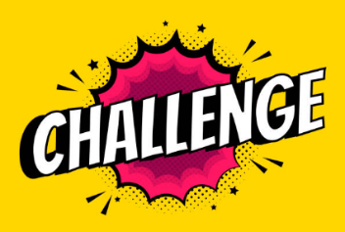

Write your own sentences using a preposition

Literacy Homework- due 6th May 2026 Challenge 1
Match the correct preposition to each picture.



