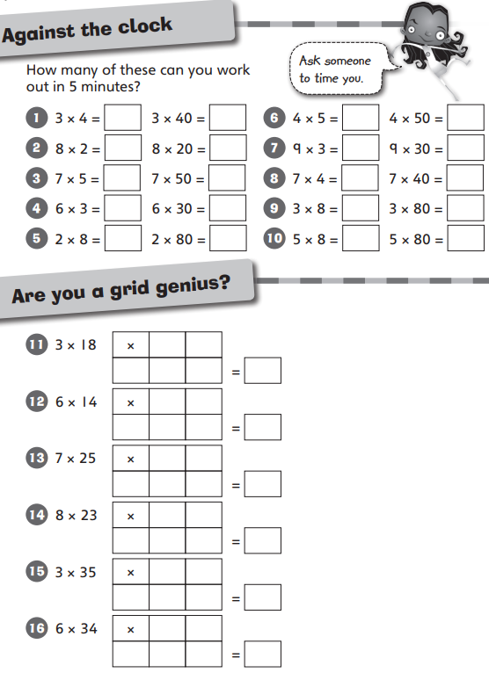
Maths homework challenge 2 Due 6/5/26

