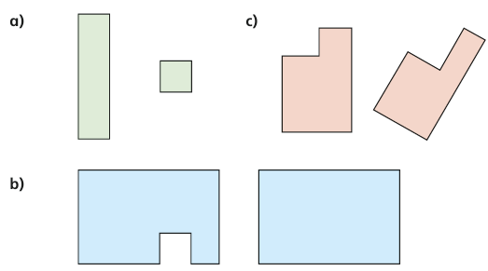
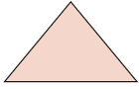
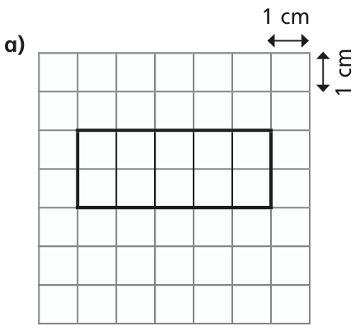
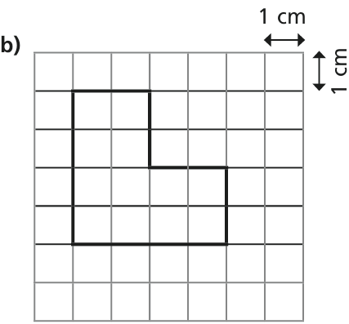
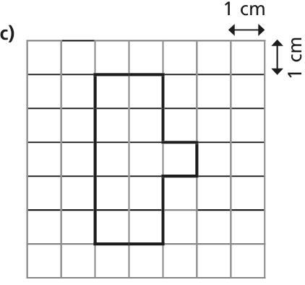
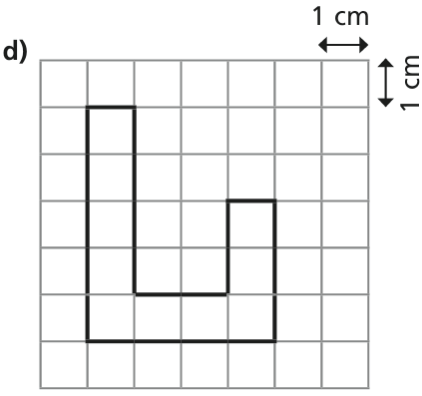

Homework
- For each pair of shapes, which has with the greater area:

- Eva draws this shape:
- Draw a triangle with a smaller area
- Draw a triangle with a greater area

- Calculate the perimeter of each shape. Remember that Perimeter is the addition of all the edges of the shape

P=
P=
P=
P=
GROUP 2

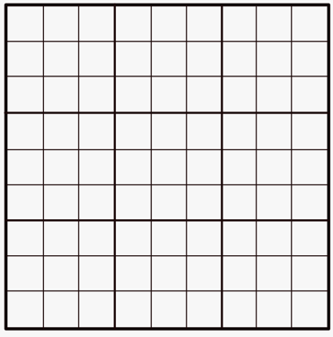
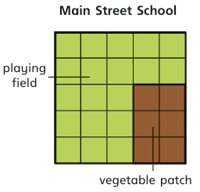
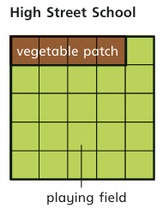
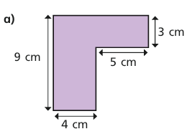
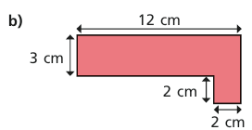
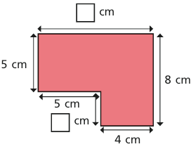

Homework
- Draw a shape with the given area:
- A= 7 squares b) A= 13 squares

- Here are plans of two school fields.
Each has a playing field and a vegetable patch

- Work out the perimeter of each shape.

- Work out the missing lengths and the perimeter of the shape:
GROUP 1
- What is the difference in the area of the playing fields? ______________ squares.
- What is the difference in the area of the vegetable patches? ___________ squares.

- High Street School doubles the size of its vegetable patch.
Main Road School adds 1 square to its vegetable patch.
Which school now has the larger vegetable patch?
P=
P=
P=

