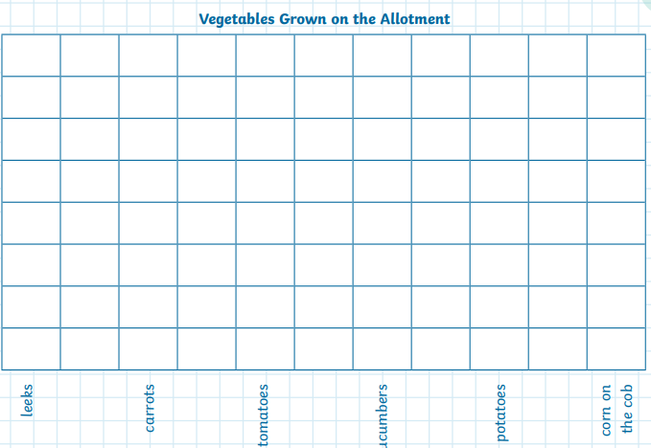
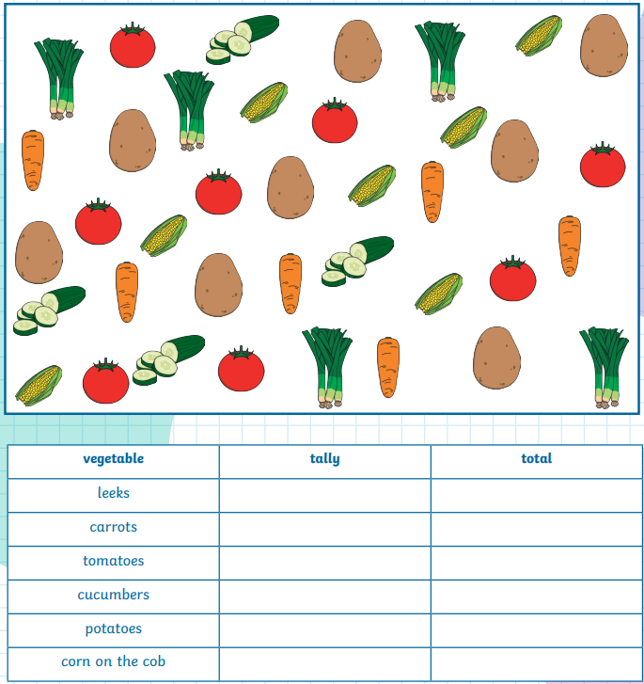
Maths homework: Due: 13.5.26
Now use the data to create a block graph.
1 block = 2 items
Count the items and create a tally

