Practise your spelling on the Emile website:
https://emile-education.com/

or, try Spelling Bee APP

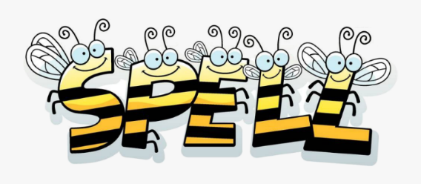
Year 3 Spellings (Summer 2)
We will continue to practise at school.
Every Friday there will be a spelling challenge.
PRACTISING

Find words within the words eg caught= hat, cat, taught

Find words within the the word
Eg separate there is a rat in separate

Rainbow words- write the rule out using different colours
caught.

Write the spelling word in a sentence.

Write out your word using bubble writing.

Challenge on 5th June | Challenge on 12th June | Challenge on  19th June | Challenge on 26th June | Challenge on 3rd July | Challenge on  10th July
*The vowel digraph ea. | *Word family –sol. | *Word families – dec, cent, milli, & micro. | *Conjunctions. | *Prepositions. | *Long /ee/ sound spelt y at the end of words.
- dream  - each  - read (present tense)  - breathe  - head  - read (past tense)  - instead  - breath  - earth  - heard | - solve  - solution  - solver  - dissolve  - insoluble  - resolute  - resolutions  - resolve  - absolute  - solvent | - decade  - decagon  - decathlon  - century  - centimetre  - centigrade  - millipede  - millimetre  - million  - microscope | - when  - before  - after  - while  - so  - because  - than  - since  - once  - until | - above  - around  - before  - below  - after  - during  - from  - in  - than  - on | - berry  - bury  - busy  - early  - February  - history  - library  - naughty  - ordinary  - probably

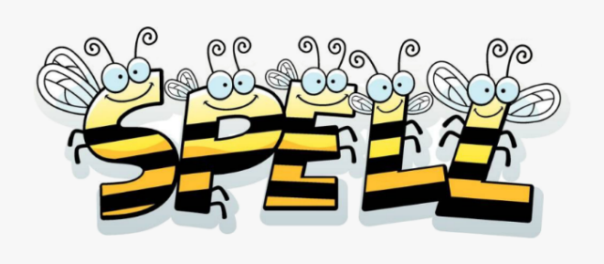
Year 3 Spelling (Summer 2)
Quiz to take place on a Friday
PRACTISING

Find words within the words eg caught= hat, cat, taught

Find words within the the word
Eg separate there is a rat in separate

Rainbow words- write the rule out using different colours
caught.

Write the spelling word in a sentence.

Write out your word using bubble writing.

Ask your teacher if you have lost
your Emile login details.

Challenge on 5th June | Challenge on 12th June | Challenge on  19th June | Challenge on 26th June | Challenge on 3rd July | Challenge on  10th July
Question words | Conditional | Double letter +y adjectives | Ordinal | Past tense verbs | -ought and -aught words
- who  - what  - where  - when  - why | - could  - would  - should  - will  - won’t | - pretty  - happy  - funny  - silly  - finally | - first  - second  - third  - fourth  - fifth | - read  - saw  - went  - flew  - heard | 1. bought  2. thought  3. brought  4. taught  5. caught

Ask
Practise your spelling on the Emile website:
https://emile-education.com/

or, try Spelling Bee APP

